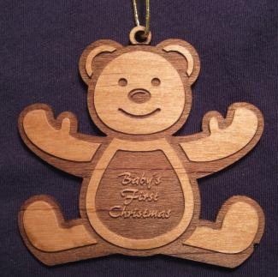 Number 1 options the bear with the words merry Christmas.

number 2 option merry Christmas and school logo, or year, or even school name.

number 3 merry Christmas with names or business name on it .

